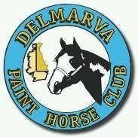  **2025 DELMARVA PAINT HORSE CLUB**

**MEMBERSHIP APPLICATION**

Name(s):________________________________________________

Address:________________________________________________

City:___________________________________ State:___________

Zip:________________

Phone:______________________ Cell: _______________________

APHA#:______________________________

Email:__________________________________________________

**DUES**:

$30 Single

$40 Family

DJPHC membership: $15 Youth 18-U

Membership entitles you to participate in all club activities.

Youth Club members MUST also be a DPHC member to receive any awards.

**Membership must be paid by May 10, 2024 to Qualify for**

**Circuit Awards, Hi-Point & Res. Hi-Point Awards For Mason Dixon Paint Horse Classic**

Please make checks payable to **DPHC** and mail to:

Lyn Fick

PO Box 88

Rock Hall, MD 21661